Name: Darshan Kalpeshbhai Prjapati

MoneyModule

Class diagram

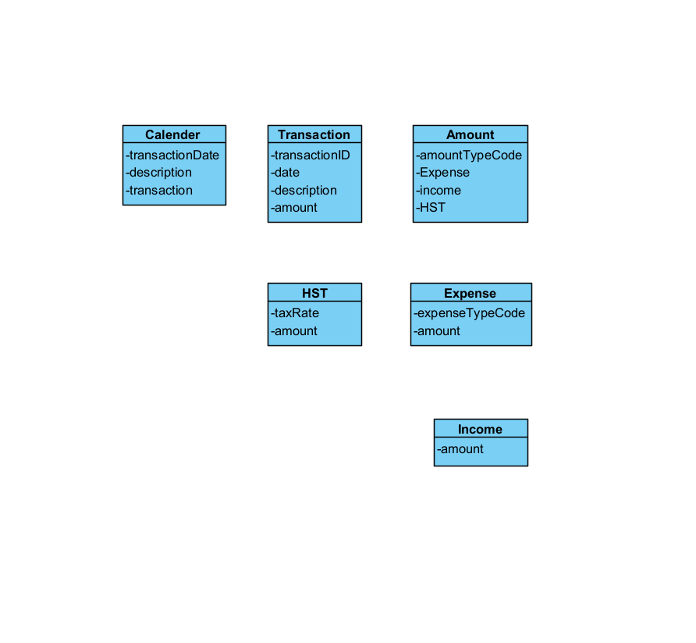

1:Create Income Transaction

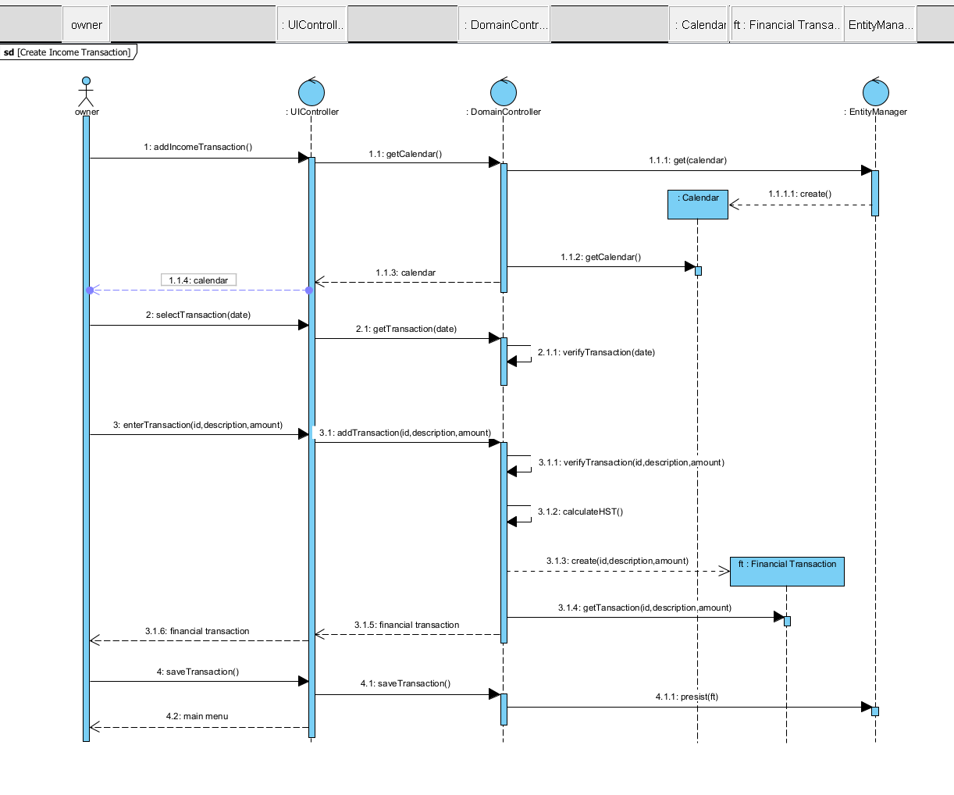

2:Create Expense Transaction

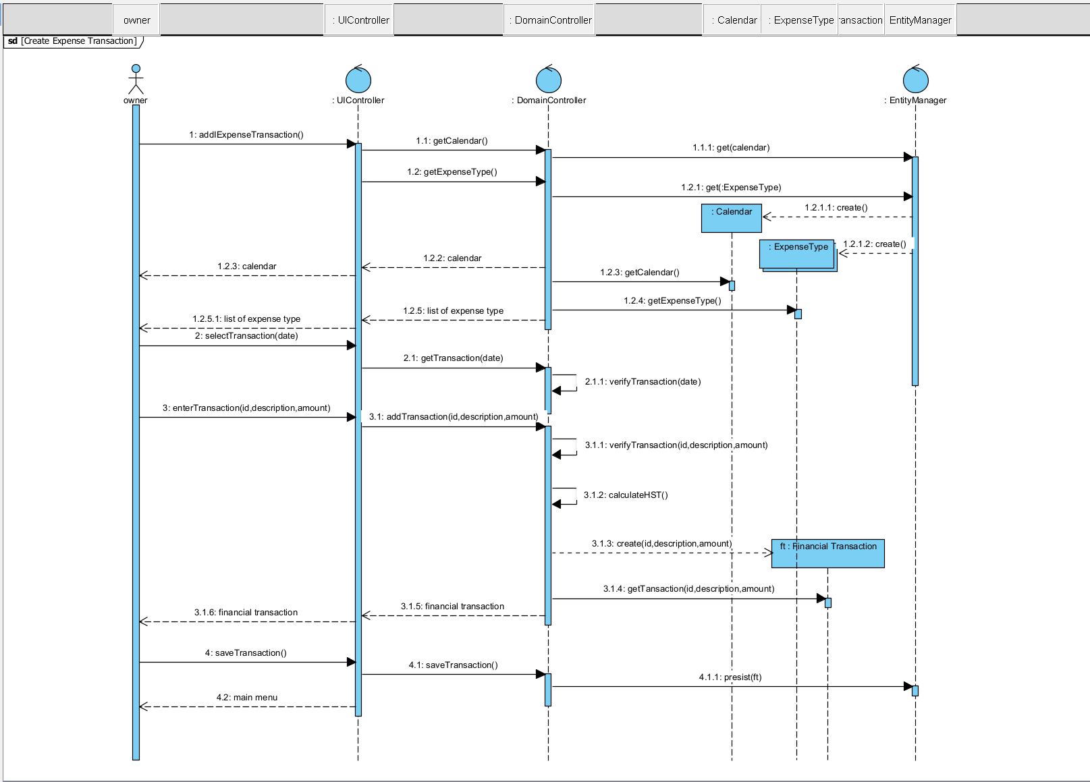

3:Query Financial Transaction

